DEPLOYMENT OF APP IN IBM CLOUD

UPLOAD IMAGE TO IBM CONTAINER REGISTRY

|  |  |
| --- | --- |
| Date | 17 Nov 2022 |
| Team ID | PNT2022TMID02585 |
| Project Name | Smart Fashion Recommender Application |
| Team Members: | Kaviya.M  Haris Ahamed MJ  Aswanth.S  Neelambiga.S |

CREATING REPOSITORY IN IBM CLOUD:

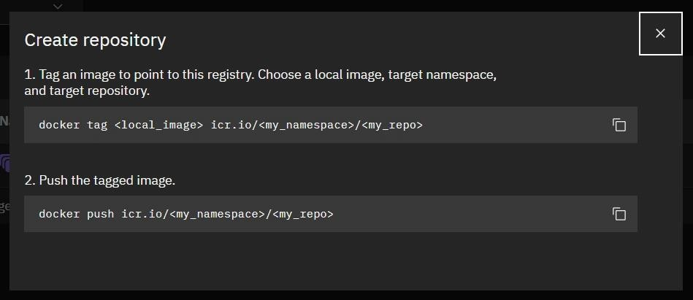

UPLOAD IMAGE TO IBM CONTAINER REGISTRY:

